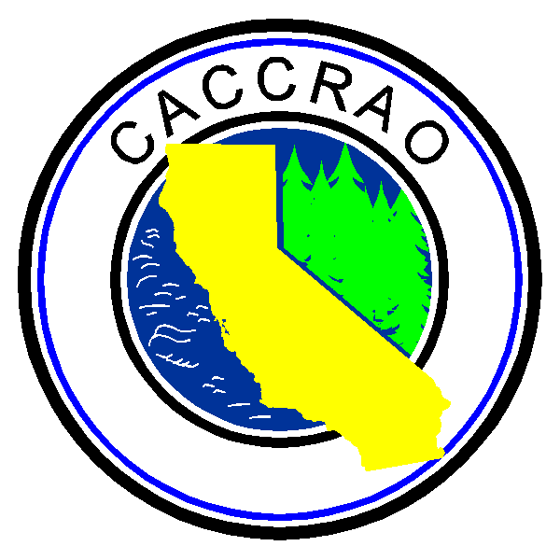
CACCRAO Executive Board Meeting
Minutes
April 30, 2008
Harrah’s Lake Tahoe

X | Sherri Hancock  President | X | Alicia  Terry  President  Elect | X | Carlo Santos  Vice President | X | Joyce Semanik  Secretary | X | Nancy Jensen  Treasurer
X | Rebecca  Dezsi  Region  1&2 | X | Wilbur  Wu  Region 3&4 | X | Catherine Mooney  Region  5&6 | X | Judith Heinrichs  Region  7&8 | X | Sue Vaughn  Past President

TIME | ITEM | NOTES | ASSIGNMENT
11:15 | Introductions | Sherri introduced the incoming reps and officers. Transition of materials was made at the meeting for those who had not done so previously.  Sherri compiled the list of e-mail addresses for the board members.
 | Financials | Sherri stated that all money collected should continue to be sent to Kristie Anderson.  Sherri briefly explained to the new board members that forms for reimbursement, etc. would be available at the first meeting. | Nancy to have financial forms for distribution to board members.
 | Board Meeting Schedule | Dates for next year’s board meetings were discussed. Sherri requested that everyone send her the dates they were available by Wed. Meetings are scheduled for a Thurs and Fri in July, September, and February. | Board to send availability for board meetings
12:00 | Adjourned

CACCRAO Executive Board Meeting
Minutes

 | Sherri Hancock  President |  | Alicia  Terry  President  Elect |  | Carlo Santos  Vice President |  | Joyce Semanik  Secretary |  | Nancy Jensen  Treasurer
 | Rebecca  Dezsai  Region  1&2 |  | Wilbur  Wu  Region 3&4 |  | Catherine Mooney  Region  5&6 |  | Judith Heinrichs  Region  7&8 |  | Sue Vaughn  Past President

